**SOLR SETUP IN LOCAL**

1. Extract solr from zip folder.
2. Go to ->D:\solr-4.10.2_brl\server\solr\patientsearch\ data-config.xml

Change db username and password:

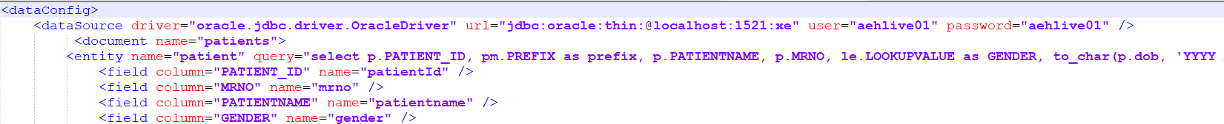

1. Go to -> D:\solr-4.10.2_brl\server\solr\patientsearch\conf\ solrconfig.xml

1. In Tomcat folder -> Go to -> D:\apache-tomcat-7.0.109\conf\server.xml  
   A screenshot of a computer

   Description automatically generated
2. Open cmd prompt -> Go to installation directory -> server folder ->

java -jar start.jar

1. Open browser - <http://localhost:8983/solr/>